# CI/CD

CI and CD are acronyms to represent modern development practices.

CI stands for continuous integration, which is a practice that focuses on developers integrating code regularly into a shared repository. Check-ins are verified by automated builds and testing to ensure bugs are caught often and early.

CD, on the other hand, can either mean continuous delivery or continuous deployment. Both are very similar but have a distinct difference. Continuous delivery is automating the release process by deploying changes on a schedule or at the click of a button. Continuous deployment on the other hand, deploys changes automatically after passing all stages of a production pipeline.

Continuous deployment and continuous delivery are very similar in practice and both are an extension of continuous integration in an automated DevOps environment.

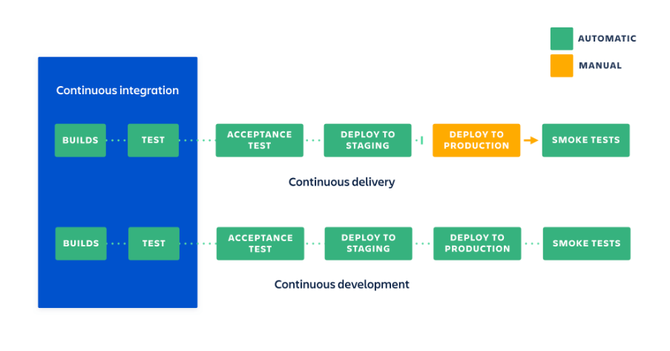

## Some tools for CD:

Many CI tools can be doubled up as deployment tools:  
  
**Jenkins:**Although Jenkins is primarily a CI server, it can be configured to be used as a deployment tool with the many plugins available to it.

Tools that are designed specifically for automated deployment:  
 **Octopus:**Octopus is an automated deployment and release management server. It is designed to simplify deployment of ASP.NET applications, windows services and databases.

**GoCD:**Go is an open-source tool to help in the continuous deployment of software. It supports several version control tools, including Git. Similar to Jenkins, plugins can be installed to extend its features. These plugins support authentication and authorization software, version control, build tools, notification and chat tools and cloud computing providers.

## Recommendation:

Although Octopus and Go are viable options: Octopus as it is the de facto for .NET applications and it integrates with Jenkins and GoCD as it is an open-source tool which can be extended with its plugins. Due to the familiarity with Jenkins, it is already being used as our CI server and with plugins we can extend its features for deployments I recommend we use Jenkins as our CD server.